**Technical Specifications:**

The data given is as follows which was provided through online file sharing. One of the data sets (shipping data) was given as a .json file and the other 2 (customers and orders) were .xls and .csv files

* **Customers** - Giving information on the customers - their Name, Age, and Country along with the ID
* **Orders** - Giving information on the items purchased by the Customers along with Order IDs and Amount spent
* **Shipping** - Giving information on the status for the orders and the shipping ID

**Schema Overview:**

*Customers* contains 5 columns giving the details of customers,

* their unique IDs,
* First Name
* Last Name,
* their Age and
* the Country they stay in

The data types of each of them are as follows:

* Customer_ID - Integrer
* First - String
* Last - String
* Age - Integrer
* Country - String

*Orders* contains 4 columns showing the

* unique Order IDs placed by each customer
* Customer ID showing which customer placed the order
* the Item for which the order was placed
* The Amount of Order

The data types are as follows

* Order_ID - Integer
* Customer_ID - Integer
* Item - String
* Amount - Decimal

Shipping contains 3 columns showing

* Unique Shipping_ID
* Custoner_IDs whose orders have been shipped/pending
* Status showing the position of the order - Pending or Delivered

The data types of them are as follows:

* Shipping_ID - Integer
* Customer_ID - Integer
* Status - String

**Data Flow and Data Model:**



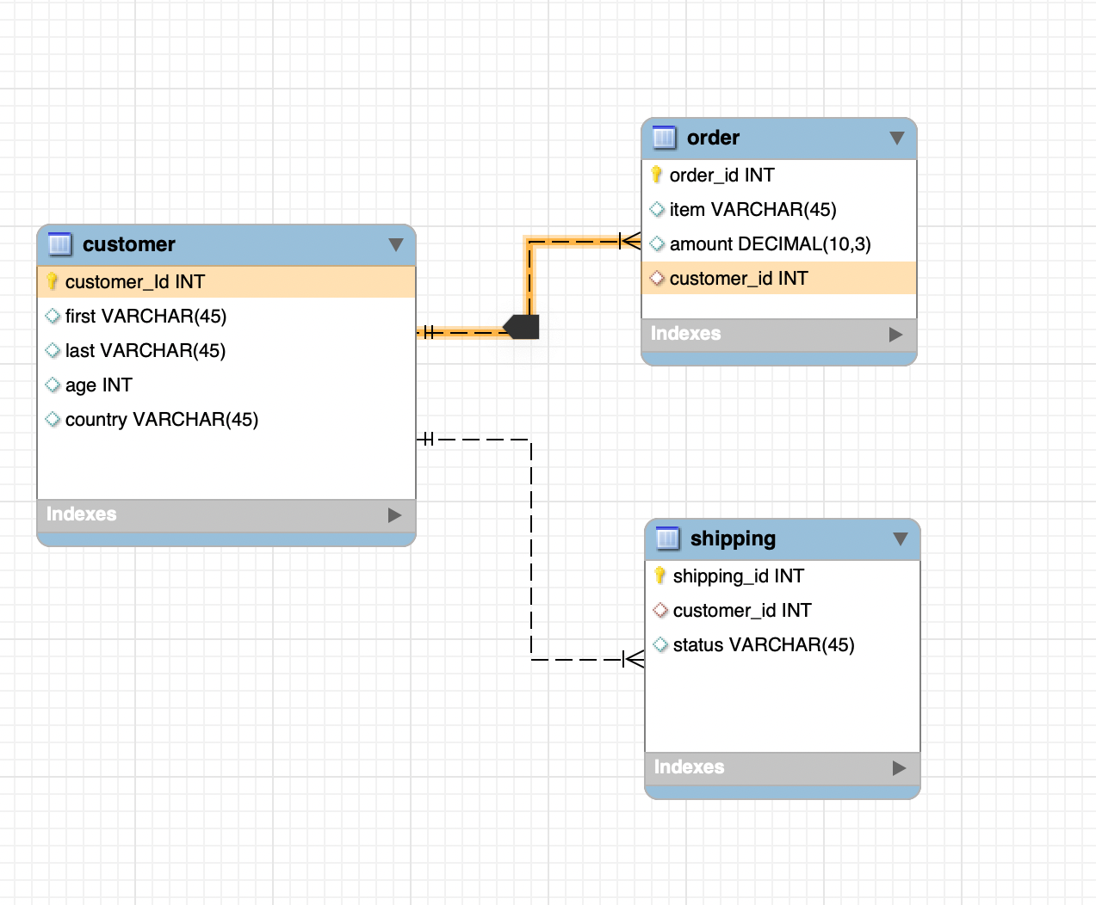

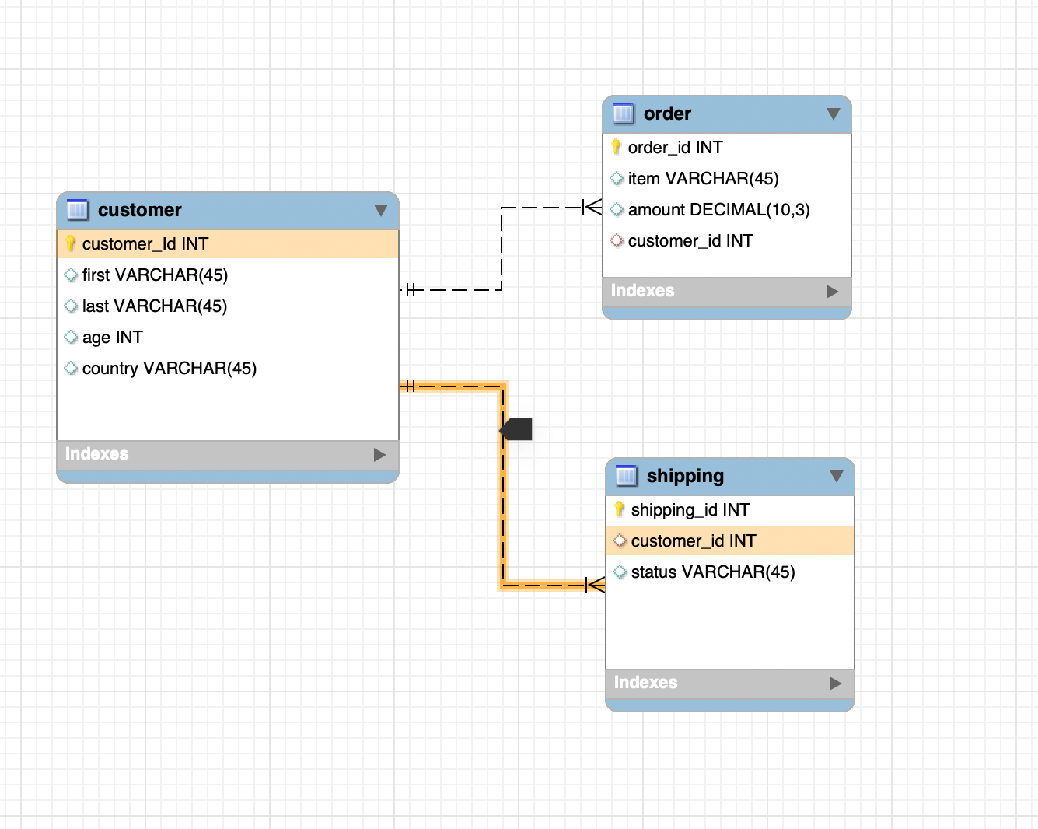

The data sets have been made using MySQL Workbench.

We can see the data model here where the 3 datasets are linked to each other. Customers is the data set which maps with both Shipping and Orders through Customer ID - they have 1:1 mapping in both cases.